

**Department of Computer Engineering,**

**Faculty of Technology,**

**Dharmsinh Desai University, Nadiad**

B. Tech. CE Semester – VI

Subject: **Object Oriented Software Engineering**

Project Title: **Online farmer crop sale/marketing**

By:

**YASH GARALA**

**CE043**

**18CEUOS078**



**Faculty of Technology**

**Department of Computer Engineering**

**Dharmsinh Desai University**

**CERTIFICATE**

This is to certify that the practical / term work carried out in the subject of **Object Oriented Software Engineering** and recorded in this journal is the

bonafide work of

**YASH GARALA (CE-043) (18CEUOS078)**

of B.Tech semester **VI** in the branch of **Computer Engineering** during the academic year **2020-2021**.

Prof. Mrudang Mehta Dr. C. K. Bhensdadia,

Assistant Professor, Head,

Dept. of Computer Engg., Dept. of Computer Engg.,

Faculty of Technology Faculty of Technology

Dharmsinh Desai University, Nadiad Dharmsinh Desai University, Nadiad

**Index**

|  |  |  |
| --- | --- | --- |
|  | **Abstract** | **4** |
|  | **Introduction** | **4** |
|  | **Software Requirement Specifications** | **5** |
|  | **Diagrams** | **14** |
|  | **Implementation Detail** | **25** |
|  | **Screen Shots** | **26** |
|  | **Testing** | **30** |
|  | **Conclusion** | **31** |
|  | **Future work** | **31** |
|  | **Reference** | **31** |

* **Abstract**

Online crop marketing system is make easy , transparent, fast marketing so every farmer get good price of own crop.

Currently all system are running manually and crop price is decided by other buyer but now crop price is decided farmer and sell it . and make easy to MSP sell. This system we added admin so admin can maintain crop so any violating contain admin can remove it and make clean web site. It user is violating any condition admin can delete this account.

* **Introduction**

Using this system Farmer or any person who want to sell or buy crop we provide easy plate form so every one can buy or sell own crop.

## Purpose

Purpose of this document is to present detailed description of online farmer crop sale and marketing. This document give detail explanation of this software

* + **Document Conventions**

document created base on IEEE templets for SRS document

* **Software Requirement Specifications**

# Overall Description

## Product Perspective

Sell Description:

From this function user can sell crop. This function make easy to sell crop using this function.

BUY Description:

From this function user can buy crop form other farmers or other user. Using this function make easy to buy crop from other user .

## Product Functions

* If user want to buy some Crop thane user can buy a crop.
* if user want to sell something then user can sell also.
* admin can manage all function and user detail .
* user login and register functions.
* User cart.

## User Classes and Characteristics

* **Farmer or customer** who want do bay or sell crop.
* **Admin** who manage user.
* **Government** Who buy crop in MSP price.

## Operating Environment

Some basic knowledge of web site and any web browser install in own device.

On developer site visual studio ,.net core ,entity frame work install in visual studio,one web browser install in own pc.

## Design and Implementation Constraints

Farms crop management system developed in .net c#. and developing this system we are using visual studio 2019. For designing purpose we using html ,css ,bootstrap.

## Assumptions and Dependencies

User know English language and user provide correct credential.

# External Interface Requirements

## User Interfaces

* Front-end :- HTML, CSS, JavaScript.
* Back-end :- C#,.NET Core framework.

## Hardware Interfaces

Minimum requirement is you have one latest updated web browser. Recommendation is chrome or Mozilla Fairfax.

## Software Interfaces

Following software we are using for creating good farmer crop selling system.

Operating System

Windows because this OS is more user friendly compeer to other OS.

Database

To save user data we user SQL database.

.NET Core

This project we are implementing in .net core

## Communications Interfaces

This project support all type of web browser.

# System Features

## User management

-Description and priority

In this user can register as a new user and log in system. after using this system user want to log out then click on logout button then they can log out in system if user want to update own profile user can update profile

### User Register

Description :-by this function user can register it self is he/she haven’t account in this web application

Precondition :- user does not have account in this web application.

Input :- all important detail that require for registering user like: username ,password, mobile number etc.

Process :- check is user name is exist in system then give appropriate message.if not then create new account.

Output :- create new account or give error message.

### User Login

Description :-by this function user can login in system then user can explore more fetchers of the system

Precondition :- user must have account in system.

Input :- user name and password.

Process :- check given user login credential is correct or no.

Output :- if user name or password is correct then redirect to home page other page if not than give appropriate message.

### Logout

Description :-user can logout it self spending valuable time on app.

Precondition :- user must have login in system.

Input :- just click on logout button.

Process :- remove all cookies and session that are store in user system.

Output :- redirect to home page.

## Crop management

-Description and priority

In this functionality user can sell or buy a crop.

### Crop Register for sell

Description :- appropriate user (farms and business man) thay can register own crop for selling

Precondition :- user must have login in system.

Input :- give appropriate detail of crop like price name of crop etc...

Process :- update database through new crop.

Output :- this crop is display in sell crop part of allocation.

### Crop Buy

Description :- government ,farmers ,business man all can buy crops.

Precondition :- user must have login in system.

Input :- just clike on buy button then give some payment option and some credentials.

Process :- crop is update in my order section and show appropriate status .

Output :- crop display in my orders section.

### Crop Setting

Description :- this function use can editing own crop detail.

Precondition :- user can not change crop id.

Input :- click on update button all new data is update.

Process :- overwrite old data .

Output :- give success of fail message.

.

## Administer management

-Description and priority

Administer have all record of crop and user if any user upload any abuse crop than admin can delete this crop and admin want to give punishment that user than admin can block user account for some period of time .

### Manage crop

Description :- admin can delete a crop. if admin detect any abuse in crop.

Precondition :- user must have login in system.

Input :- click on delete button and give appropriate reason for deleting crop.

Process :- update database .

Output :- crope is deleted from crop detail.

### Manage user

Description :- admin can block the user for a some time.

Precondition :- admin must have login this sytem.

Input :- click on block user button and give appropriate reason and time.

Process :- user account status is change to block.

Output :- user can not buy or sell new crop for a some period of time.

### Admin login

Description :- admin login through other page .

Precondition :- admin must have account in.

Input :- username and password .

Process :- check user account is exist or not.

Output :- reflect appropriate message .

## Government

-Description and priority

In this application we are involving government because.

### Crop Buy in minimum support price grant

Description :- government buy crop from farmers in MSP grant .

Precondition :- government must have login in system.

Input :- buy more than one crop.

Process :- update database .

Output :- crop was not display in sell part .

### Registering for frames in Minimum Support Price grant

Description :- those farmer want to sell own product as a MSP they need to register in.

Precondition :- farmers must have account in our application.

Input :- give require detail of government needed.

Process :- update database.

Output :- crop data was display to government database .

## User Cart

-Description and priority

If user want to buy more than on item then they us this.

### Add to cart

Description :- in buy part of the our web application .click on add to cart button item is added to cart.

Precondition :- user must have login in system.

Input :- just click add to cart button.

Process :- update database .

Output :- crop is add in cart.

### remove to cart

Description :-user want to remove crop from cart user can remove it.

Precondition :- user must have login in system.

Input :- click on remove form cart.

Process :- update database .

Output :- crop is removed from cart.

### Place order from cart

Description :- after adding item in cart user can place order of those multiple item .

Precondition :- user must have login in system.

Input :- click on place order.

Process :- update database .

Output :- crop is updated in my order.

# Other Nonfunctional Requirements

## Performance Requirements

* + If multiple user are logged in application but application will work fine
  + Throughput is high.
  + This application is work 24*7

## Safety Requirements

We will add later.

## Security Requirements

* Those functionality login required user can not enter without login.
* And user must know user name and password. for login.

## Software Quality Attributes

* Availability: This application will be available for any time.
* Maintainability: The administration will be maintain this application.
* Usability: any number of user can use this application.

**ER Diagram**

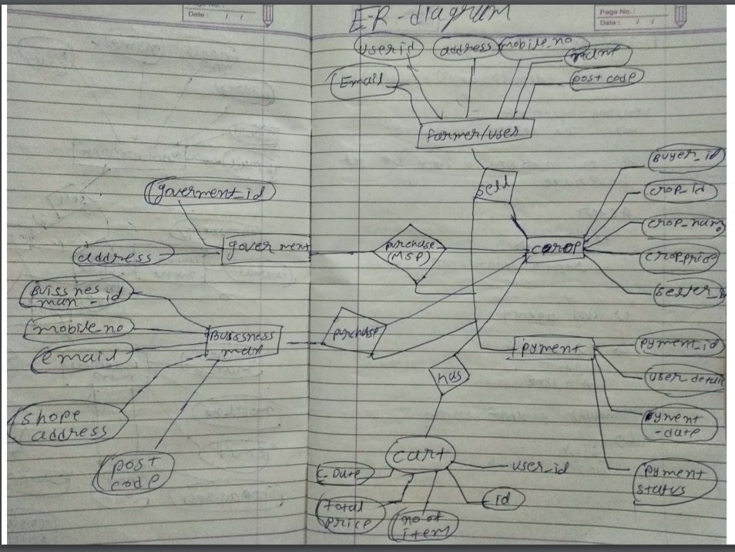

**Use case Diagram**

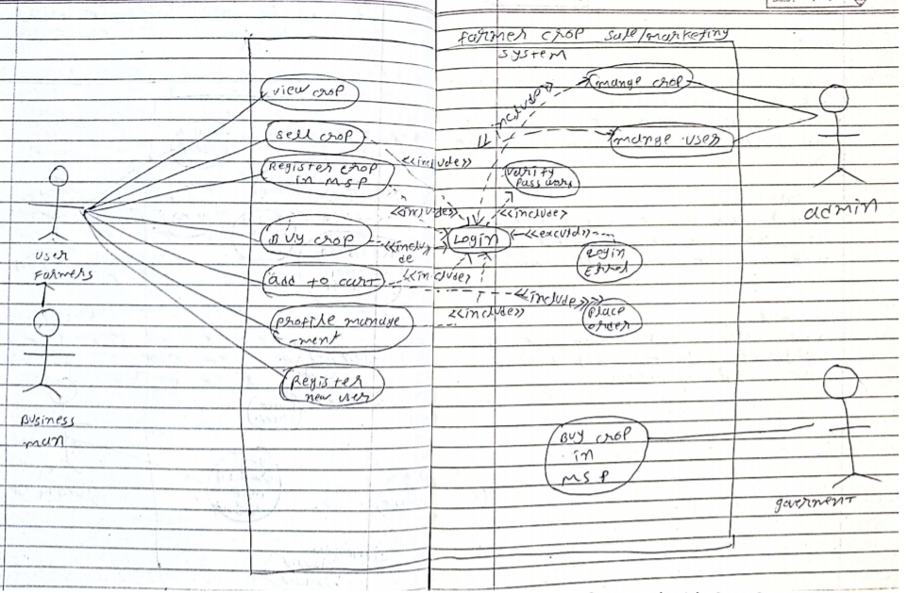

**Class Diagram**

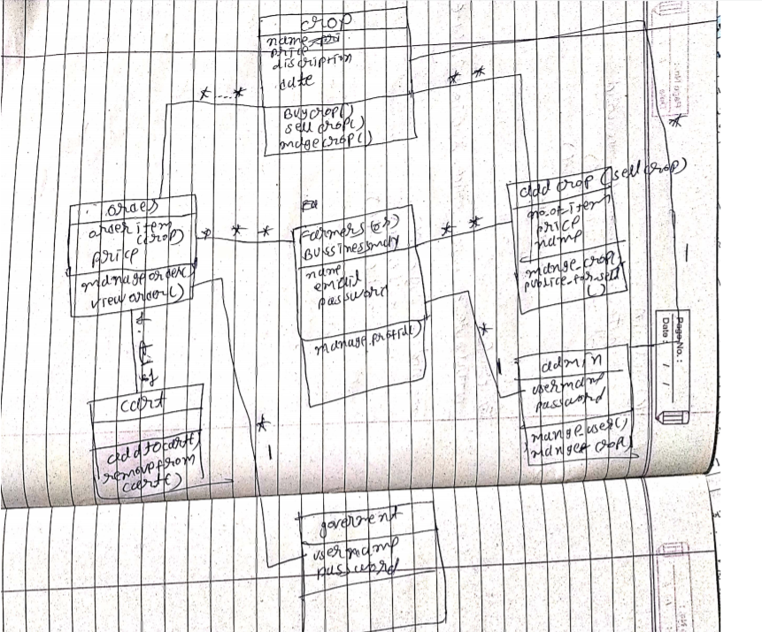

**State Chart Diagram**

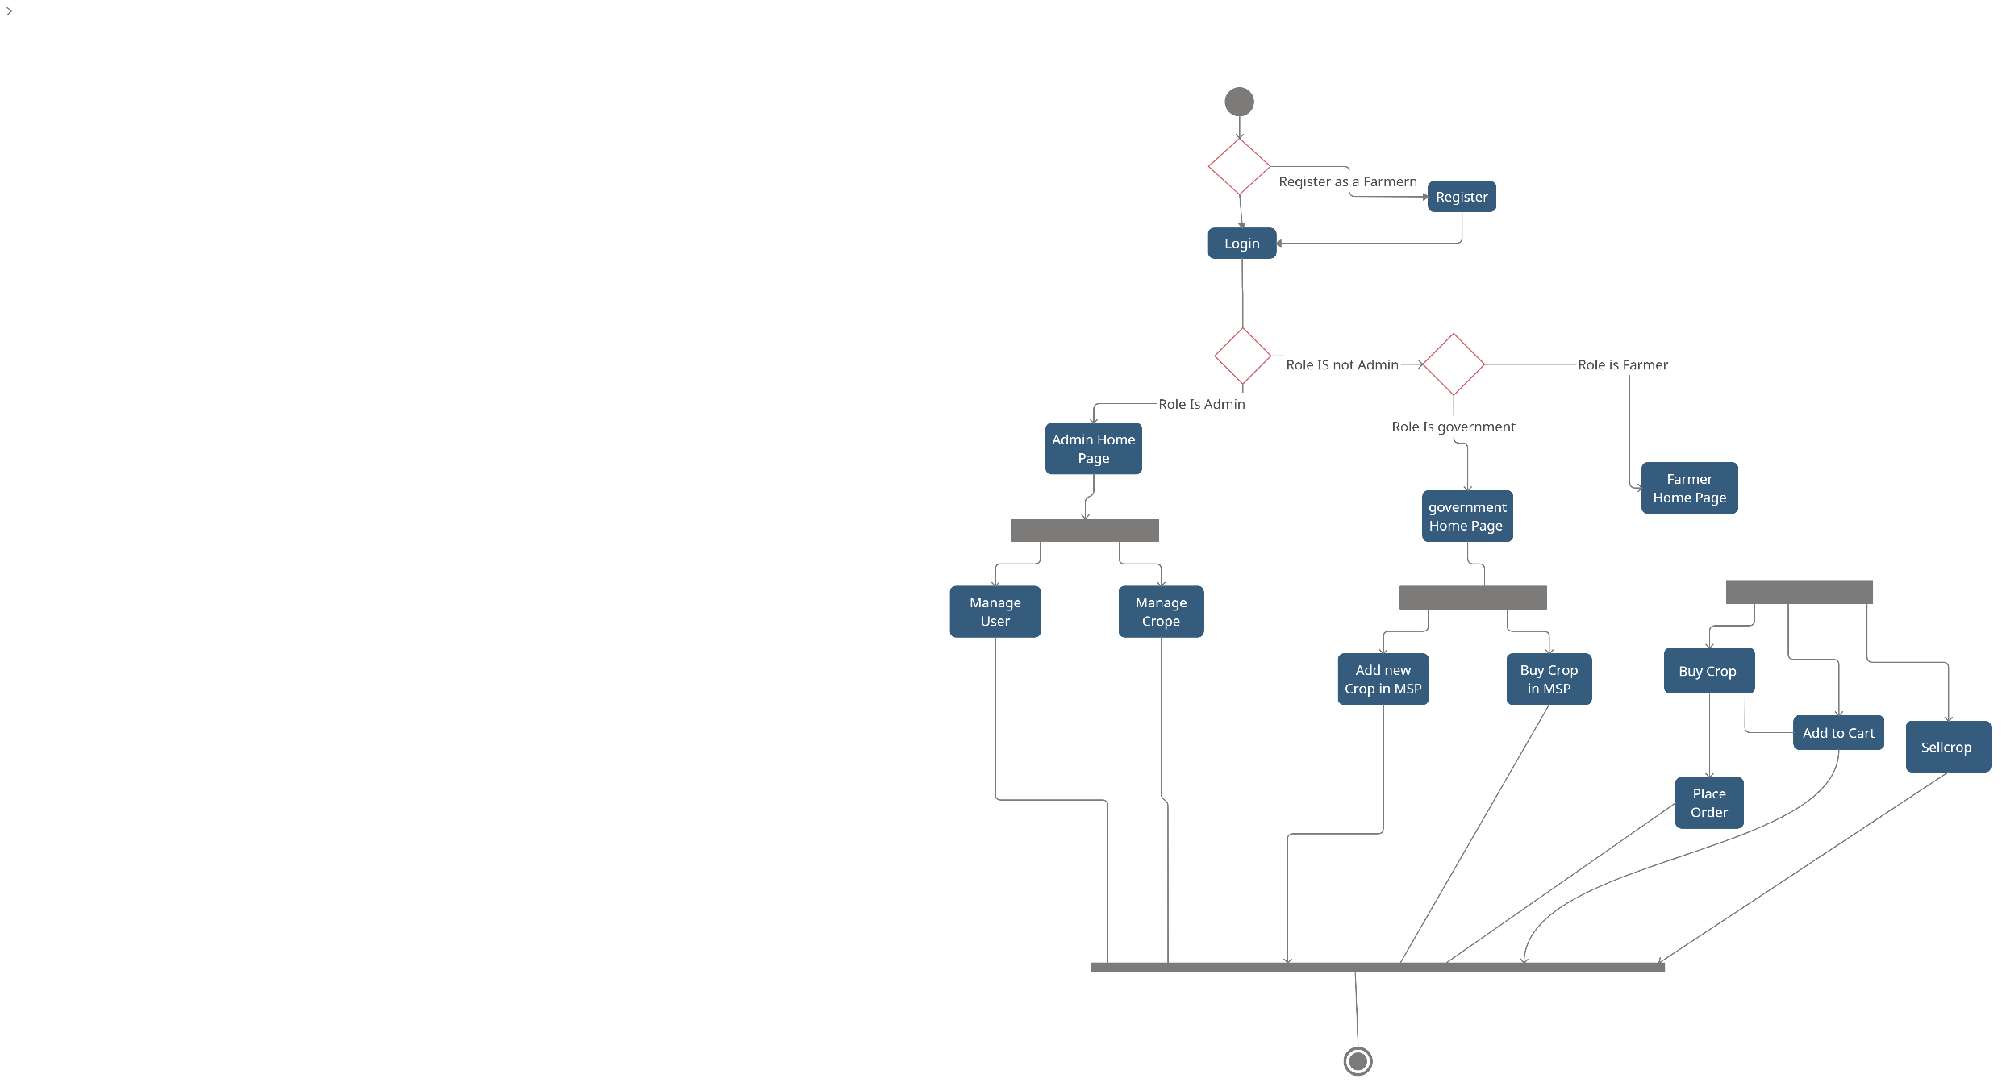

**Activity Diagram**

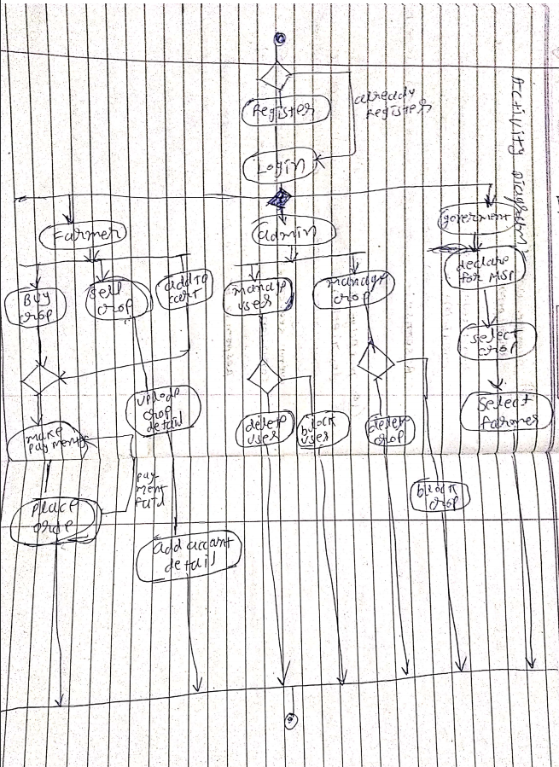

**Sequence Diagram for Farmer**

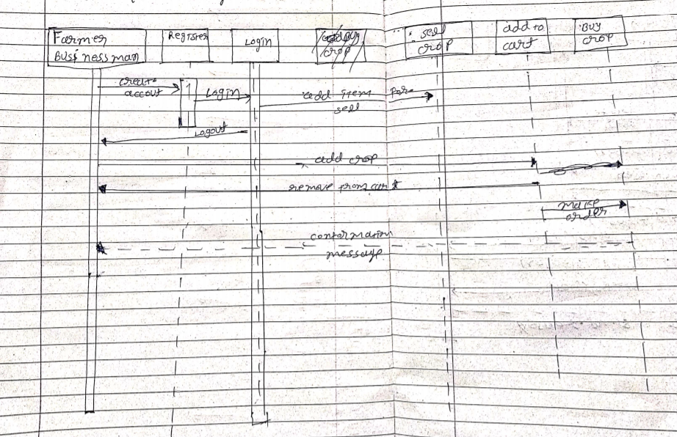

**For Government**

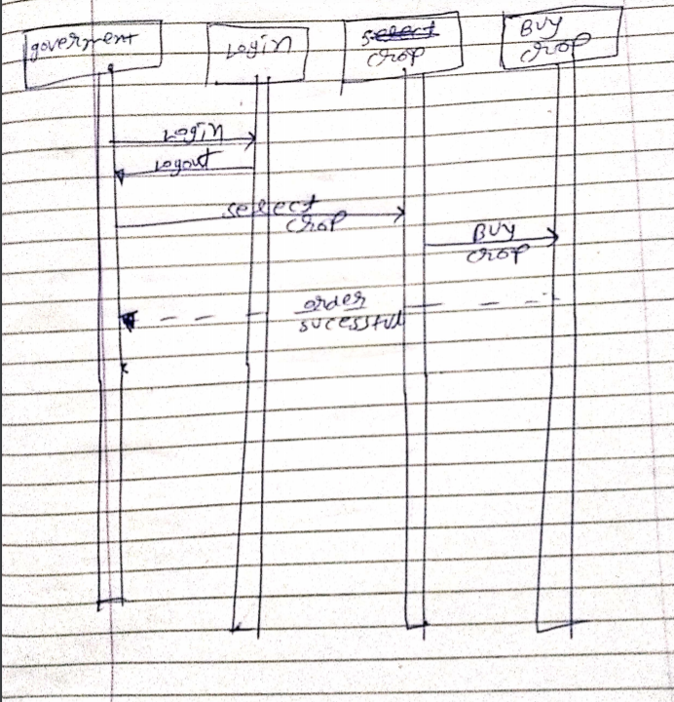

**For Admin**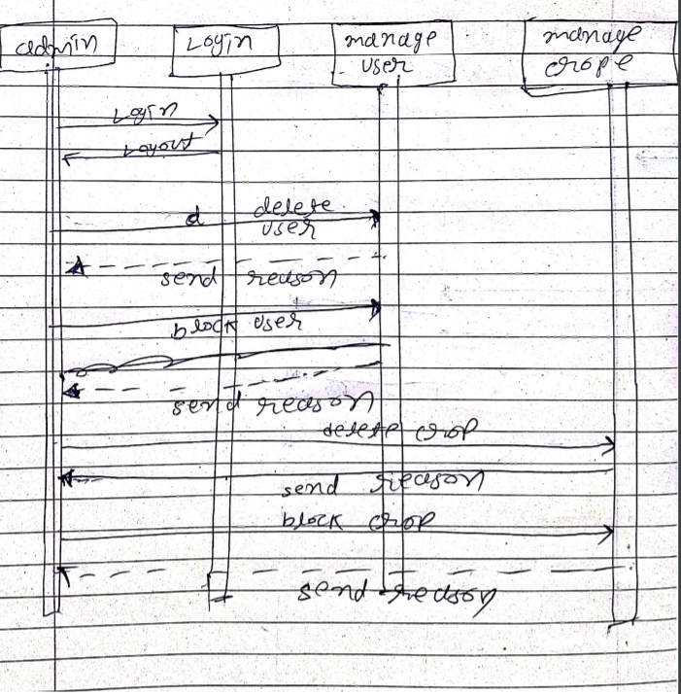

**Coloration Diagram**

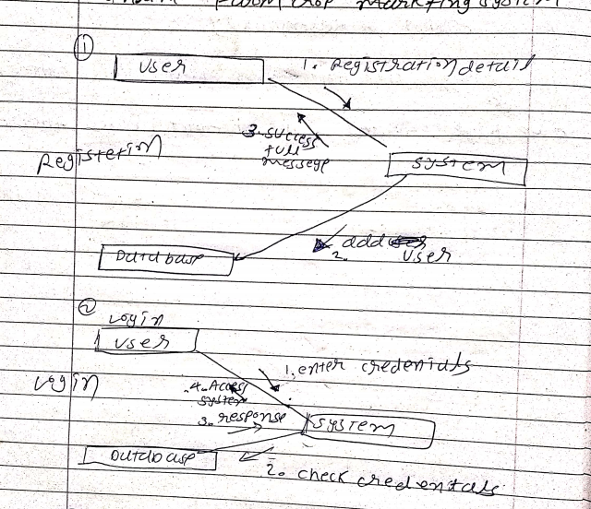

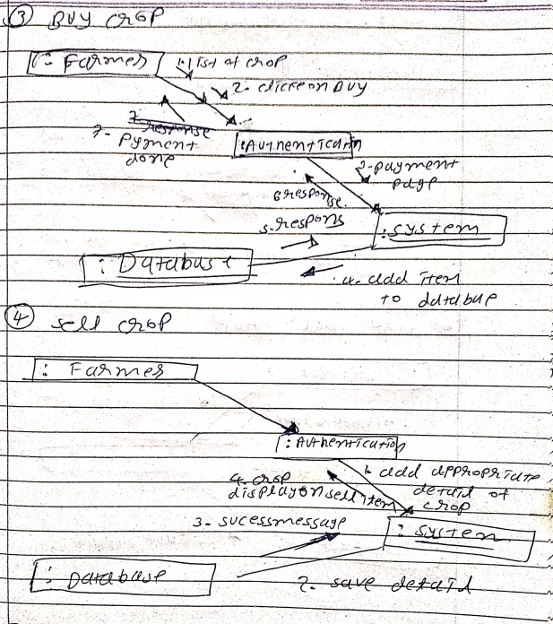

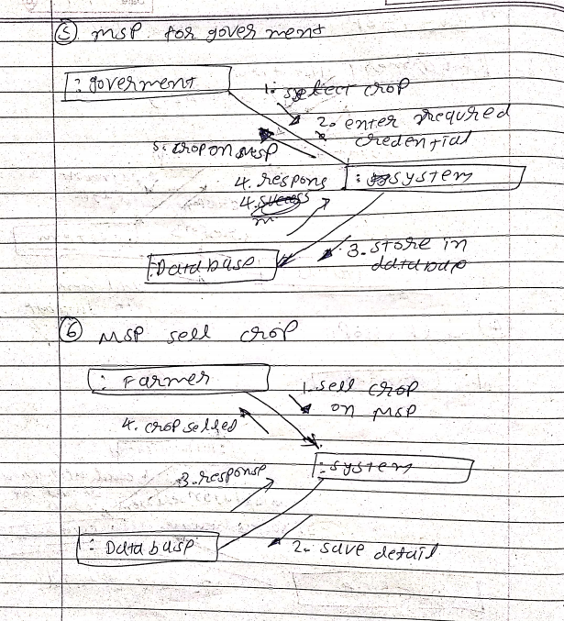

**Deployment Diagram**

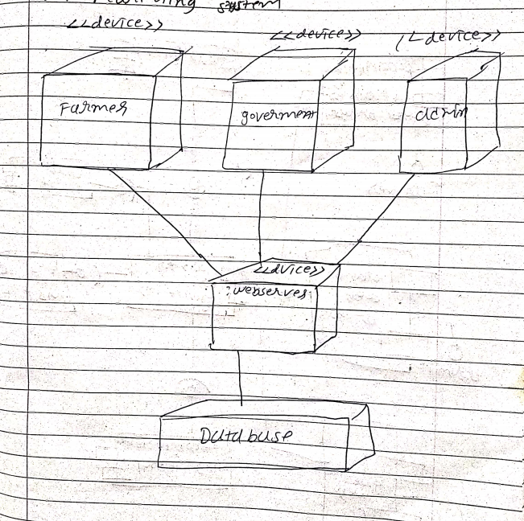

**Component Diagram**

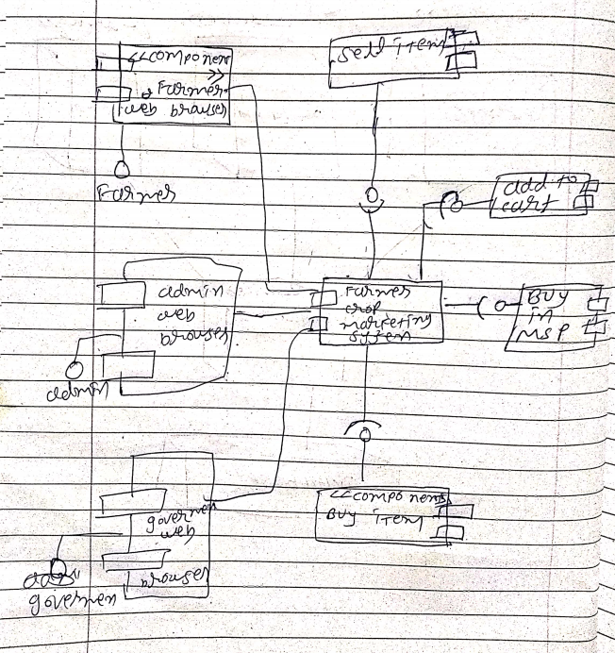

**Implementation Detail**

Login()

Use to validated user account and if valid redirect to home page

Register ()

Use to Create new user and if user already exist that user display appropriate message.

Register ()

Use to Create new user and if user already exist that user display appropriate message.

Deleteuser()

Delete user from system.

DeleteCrop()

Delete Crop from system.

BuyCrop()

It is use for buy crop. This function is work only if user is login.

SellCrop()

It is use for Sell crop. This function is work only if user is login.

Addtocart()

If user want to buy multiple item than user add item in to cart.

Placeorederfromecart()

If user want to place order from cart.

Removefromecart()

Item remove from cart.

Mybuyitem()

Return all item that are buy by me.

Mysellitem()

Return all item that are sell by me.

**Screen Shots**

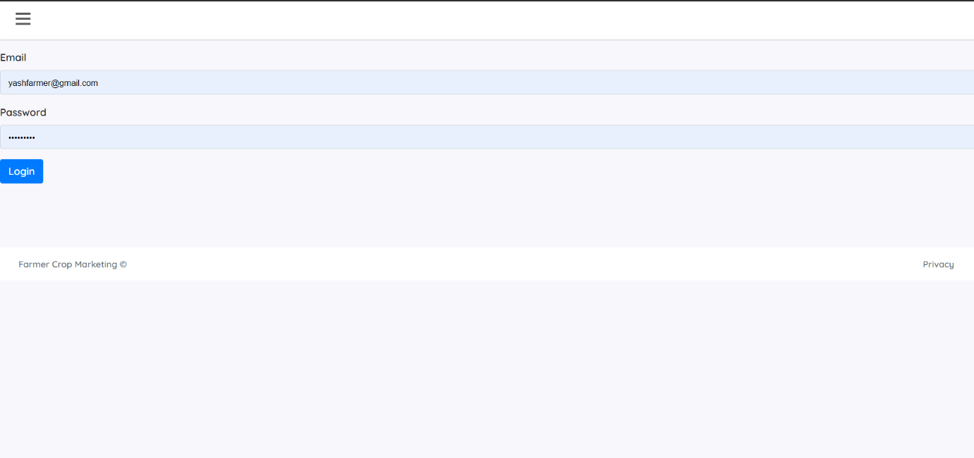**Login**

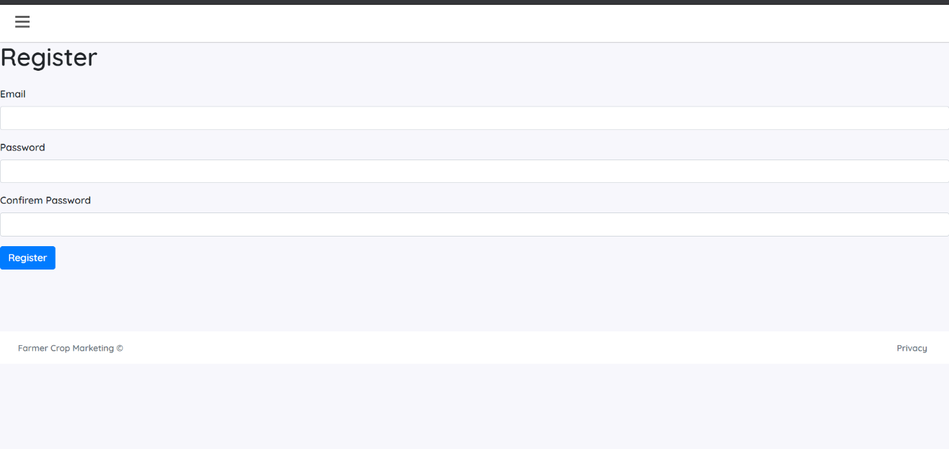

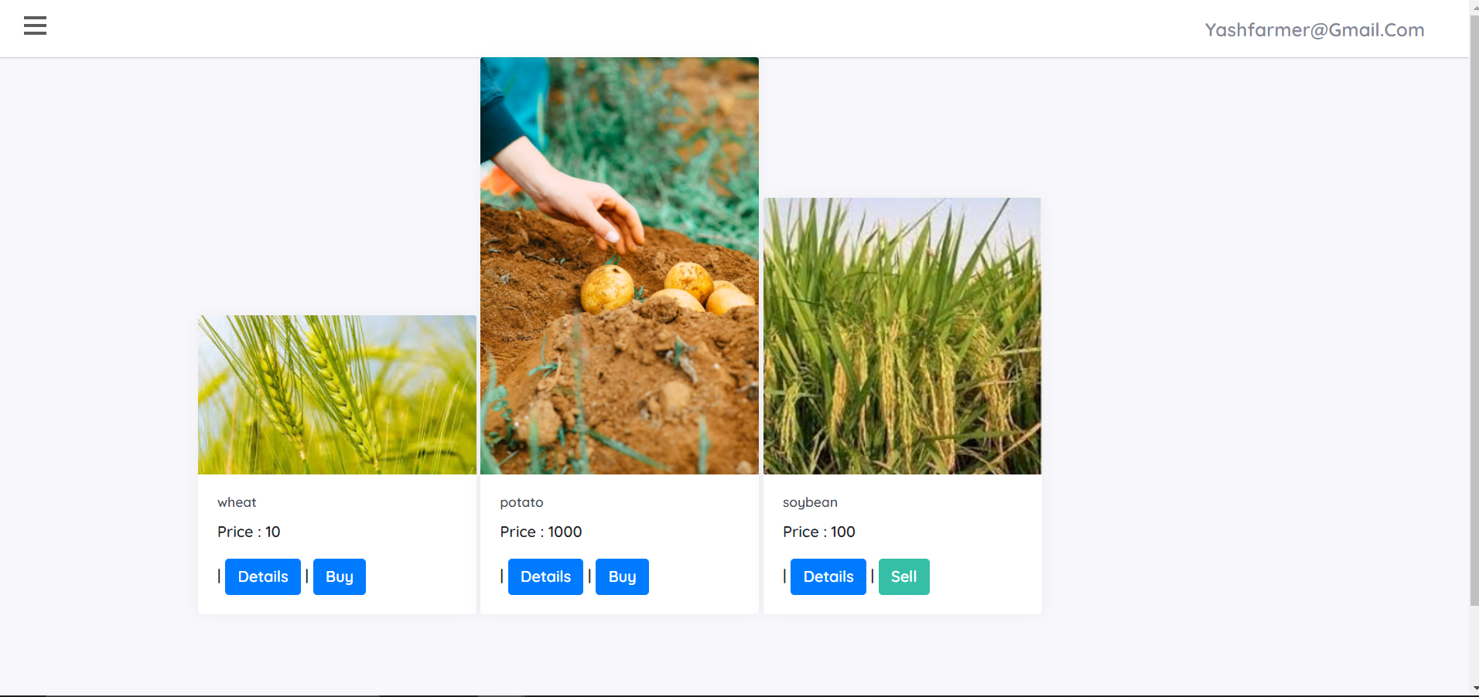

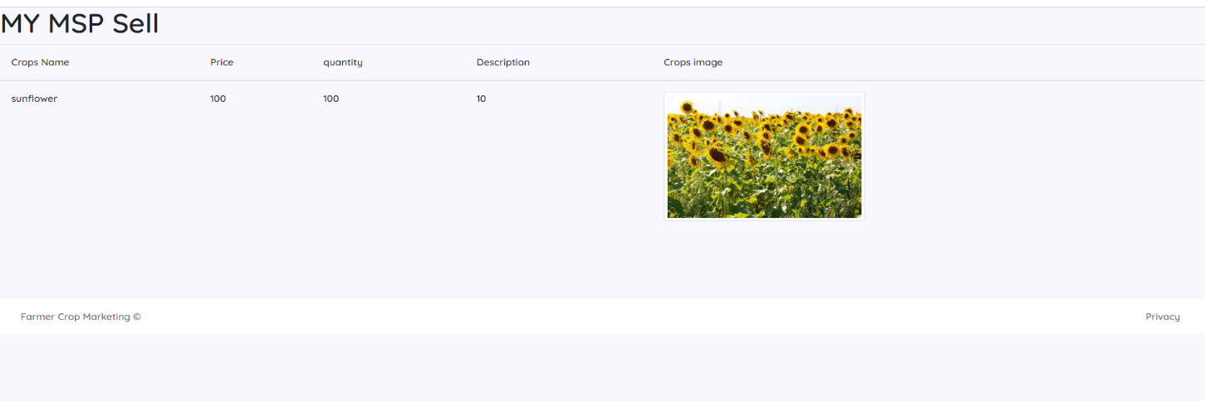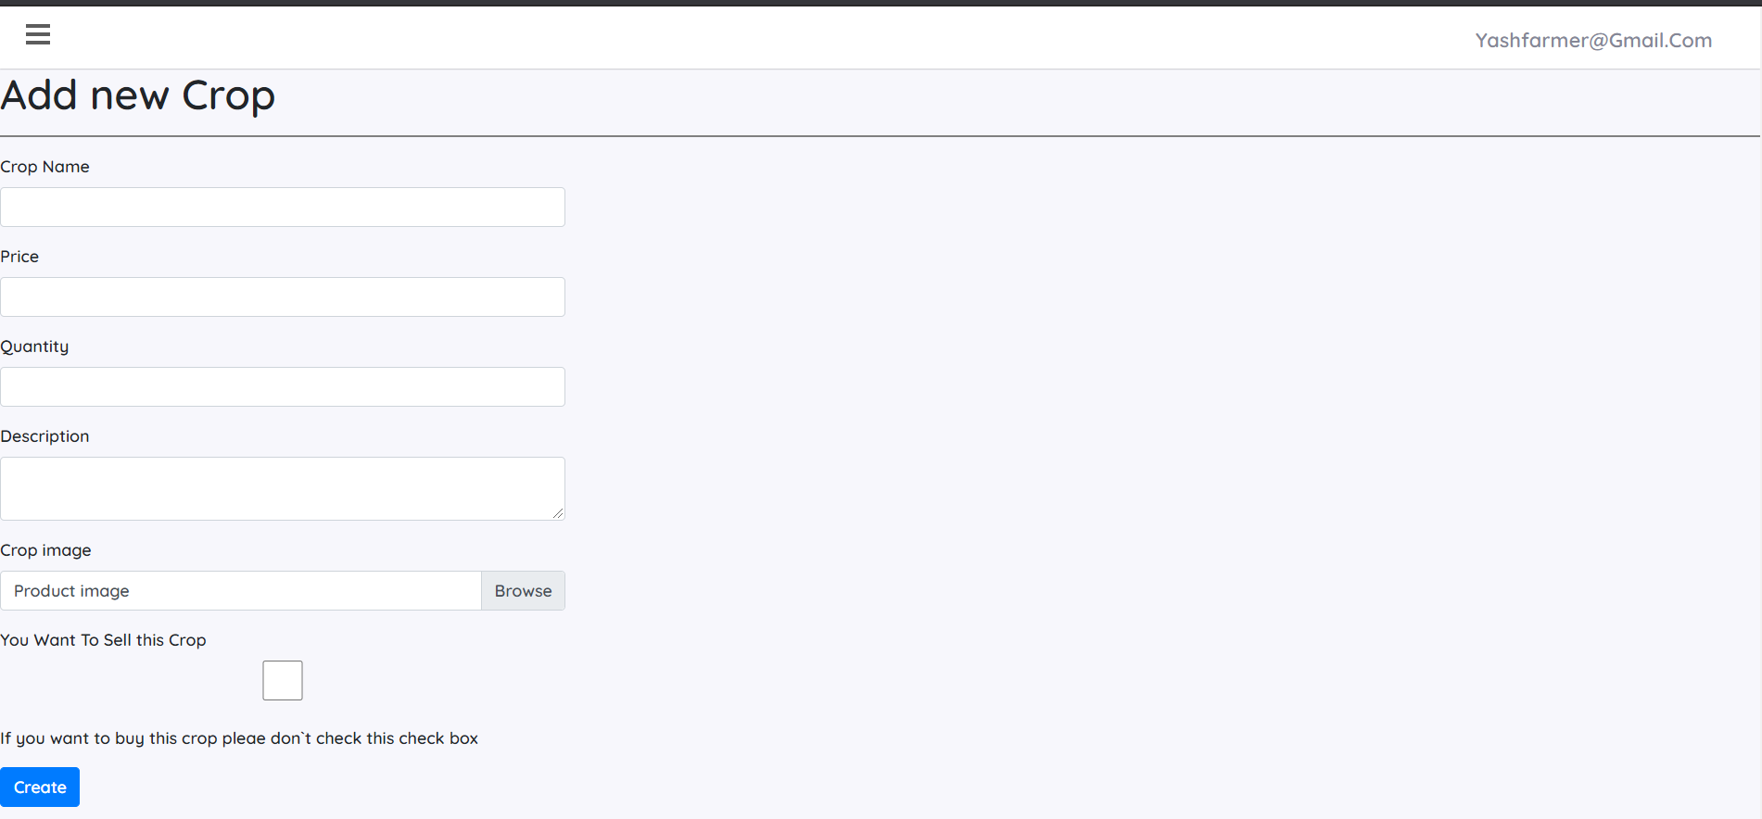

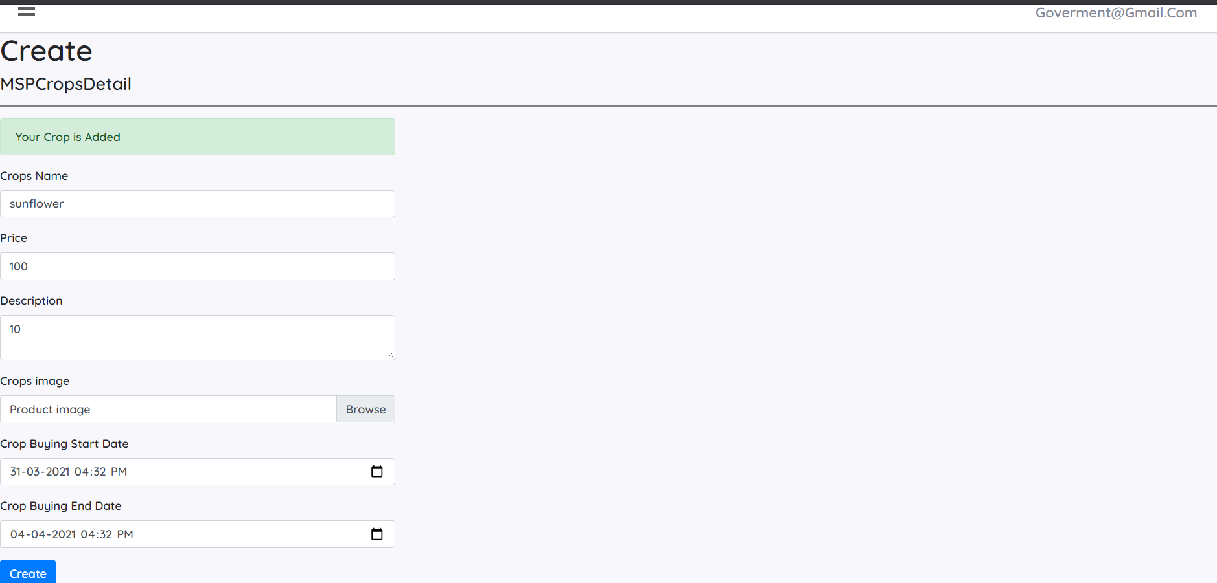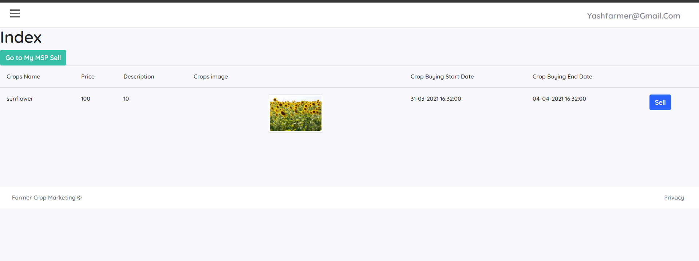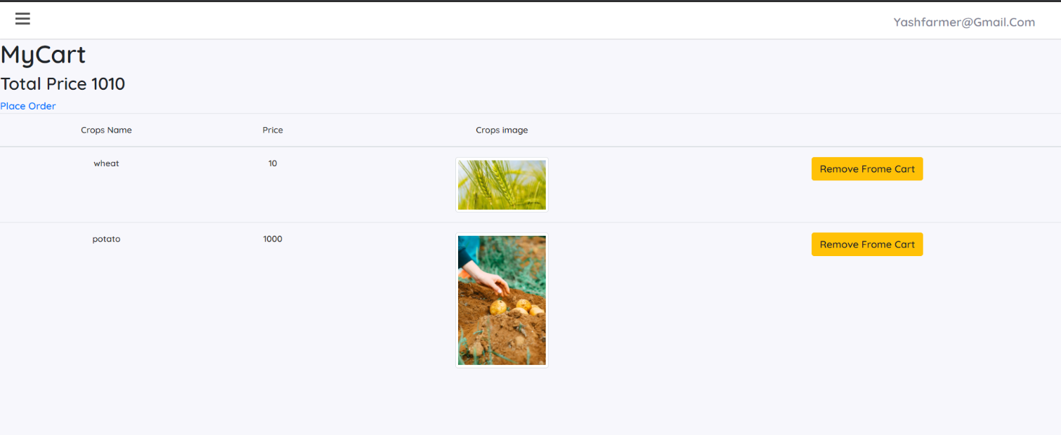

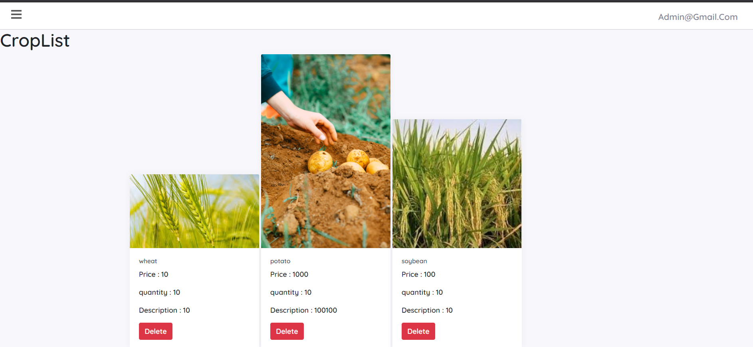

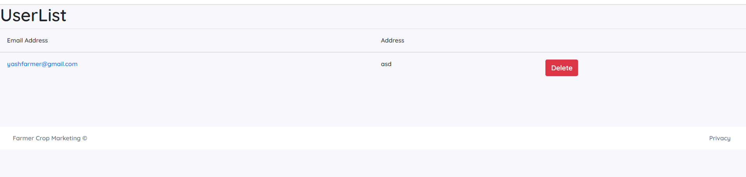

**Testing**

|  |  |  |  |  |
| --- | --- | --- | --- | --- |
| **Model Name** | **Description** | **Expected Output** | **Actual output** | **Success or Fail** |
| Login | All data are correct | Redirect to home page | Redirect to home page | Success |
| Login | If credential are not correct | Invalid login attempt | Invalid login attempt | Success |
| Register | Everything is fine | Redirect to Login page | Redirect to Login page | Success |
| Register | -User already exist  -Password is not complex as over requirement  - conform password and password are not same | -Show appropriate message  -stay in same page | Show appropriate message  - stay in same page | Success |
| Add new crop For Sell boy Buy | Everything is fine | Crop is Added for Sell or Buy | Crop is Added for Sell or Buy | Success |
| Add new crop For Sell boy Buy | If Required is not given by user or user is not login | please add required detail or redirect to Login page | please add required detail or redirect to Login page | Success |
| Place order in to cart | Display all crop are not sell and user added in cart | Click on place order  Order will be placed . | Click on place order  Order will be placed . | Success |
| Delete user | If user violation any condition | User account deleted | User account deleted | Success |
| Delete crop | If Crop violation any condition | Crop will deleted | Crop will deleted | Success |

**Conclusion**

After doing this project I conclude that using this application farmer and government work will be fast as compare to current situation. and I learn real word farmer crop selling system.

**Future work**

in future we add google authentication. We host in online cloud. we add forgot password.

**Reference**

1. [**https://docs.microsoft.com/en-us/aspnet/core/data/ef-mvc/sort-filter-page?view=aspnetcore-5.0**](https://docs.microsoft.com/en-us/aspnet/core/data/ef-mvc/sort-filter-page?view=aspnetcore-5.0)
2. [**https://docs.microsoft.com/en-us/aspnet/core/mvc/overview?view=aspnetcore-5.0**](https://docs.microsoft.com/en-us/aspnet/core/mvc/overview?view=aspnetcore-5.0)
3. [**https://docs.microsoft.com/en-us/dotnet/api/system.net.mail.smtpclient?view=net-5.0**](https://docs.microsoft.com/en-us/dotnet/api/system.net.mail.smtpclient?view=net-5.0)
4. [**https://www.w3schools.com/css/**](https://www.w3schools.com/css/)
5. [**https://getbootstrap.com/**](https://getbootstrap.com/)
6. [**https://www.freecodecamp.org/news/asp-net-core-mvc-course-net-5/**](https://www.freecodecamp.org/news/asp-net-core-mvc-course-net-5/)